## Modules

* + 1. **Module 1: Profile Management**

This module focuses on account creation and management of Users and Security Person Accounts. After signing into their accounts, an individual user can toggle portals. Each portal will manage its respective domain.

##### Sign Up

The users will have to sign up for a new account to use the application.

##### Log In

The users will log in to their accounts when they want to use it.

##### Sign in Via Phone

The Users will log in using their phone number.

##### Sign in via Guest

The users will login as a Guest.

##### Sign in Via Voice

The User will login by using their voice.

##### Update Profile

The users will be able to view and edit their personal information saved in the application.

##### Logout

The users can logout from their accounts in the application.

##### Delete Profile

The users will be able to delete profile that is saved in application.

* + 1. **Module 2: Place a Voice Record**

This module focuses on Adding voice to the system and later the voice will be be converted to image.

##### Record Voice

The users can record voice by using mic in system.

##### Upload Existing Voice

The User can upload previous voice that is saved in system.

##### Upload Existing Video

The users can Upload Existing video that is saved in system. The voice can be fetch from video and late converted to image.

##### Update Voice

The users can Update voices that is saved in system.

##### Delete Voice

The users can delete saved voice in the system.

##### Update Video

The users can update videos that is saved in the system.

##### Delete Video

The users can delete saved videos in the system.

* + 1. **Module 3: Sound to Vector Model**

This Module Focuses on how the image will be converted to Vector by using deep learning.

##### Sound to Vector

In this use case the sound will be converted to vector.

##### Generation Of Vector Model

In this use case the vector model will be generated.

* + 1. **Module 4: Vector to Image Model**

This Module Focuses on how the Vector will be converted to Image by using deep learning.

##### Vector to Image Model

In this use case the Vector will be converted to image.

##### Generation Of Image

In this use case the Image will be generated.

* + 1. **Module 5: Image View Customization**

This Module Focuses on how the image will be customize from user end.

##### Brightness Control

In this use case the brightness of image can be adjusted according to user’s need.

##### Saturation Management

In this use case the Saturation of image can be adjusted according to user’s need.

##### Skin Color Management

In this use case the color of skin can be adjusted in image.

##### Filters

In this use case User can add filters to image.

* + 1. **Module 6: Features Enhancement**

This Module add some special access to Security person to enhance image after generation.

##### Nose Enhancement

In this use case the Nose of person can be adjusted.

##### Eye Enhancement

In this use case the eyes of person can be adjusted.

##### Face Shape Enhancement

In this use case the Shape of person can be Enhanced.

##### Eyebrow Enhancement

In this use case the eyebrows of person can be adjusted.

##### Beard Maker

In this use case beard can be add to image.

* + 1. **Module 7: Insight Panel**

This Module adds access to Security person to check the system.

##### View Report

In this use case the User can view report.

##### Download Report

In this use case the user can download report.

##### Share via Socials

In this use case the user cam share report on social media.

* + 1. **Module 8: Feedback Panel**

This Module Specifies some settings and configuration and also related about feedbacks.

##### Sent Feedback

In this use case the User can sent feedback to Management team and rate the system.

##### View Feedback history

In this use case the user can view the history of their feedbacks.

##### Dark Mode

In this use case the user can apply dark mode to the system.

##### Change language

In this use case the user can change the language of System.

##### Privacy Policy

In this use case the user can Privacy Policy of system.

* + 1. **Module 8: Help and Support**

This module will cater the application users’ queries related the application itself. Using artificial intelligence and machine learning, a bot will handle the questions from the users. The users may want to engage with an actual person, so the bot can redirect the user to live chat as well. Contact information of support team will also be available on the portal.

##### Chat with AI Bot

The bot will handle queries of the users regarding the use of application.

##### Contact Support Team

The support team’s contact information will be available.

##### Change Bot’s Language

The Bot’s language can be changed by the users.

##### View Bot’s Query history

The query history can be vied by user.

# System overview

###### Figure 1: Context Diagram of Speech2Face System

Speech2face is a web and mobile application-based software that is mainly built to recognize the face general structure, ethnicity, and gender with the audio waves. There are two actors of this system i-e general user and Security agencies. The Security person has some special access in this this system.

The User can add a voice to the system and then sound will be converted to vector model using deep learning. Later, the vector model will be converted to image generation which is the purpose of this application.

After Generation of image the user has some access to add some features like he/she can control brightness, saturation, add some filter etc. Similarly, Security person has some special access like he/she can enhance the image according to their need.

The User has access to setting and configuration option where he/she can add feedback and rate the system according to their experience. In case of any query User has option to contact management team or bots are also available in this regard.

* 1. **System Architecture**

The System has a **Model View Controller (MVC) architecture.** The system will have static pages or menus which will be viewed by the user. All the independent pages of the View will be connected to the Controller of the system which will manage the sequences of instructions added by the user. The Model of the system is the database which will be used to store data. The model will update anything on the view based on the queries. The Controller will take the query to the model in order to fetch data.

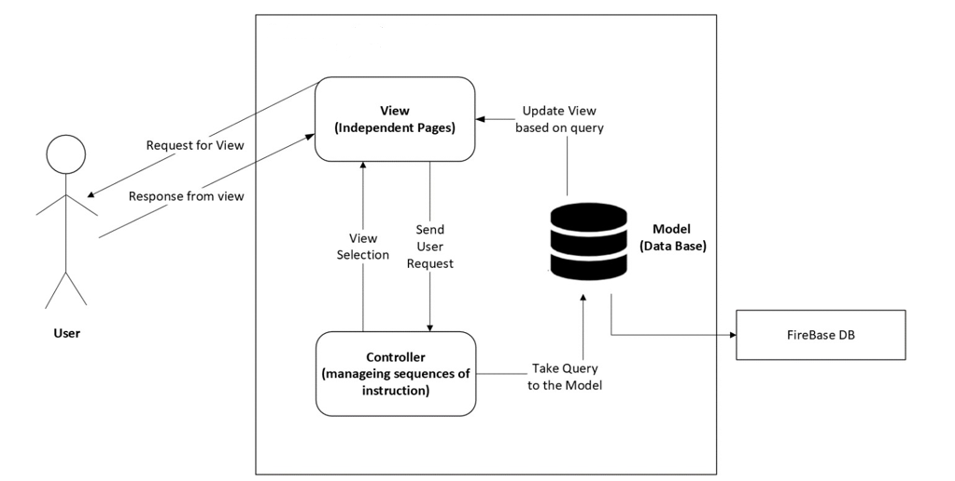

###### Figure 2: System Architecture Diagram

* 1. **Process flow/Representation**

Following are some of the activity diagrams of the application **“Speech2Face System”:**

##### Module 2: Place a Voice Record

###### Figure 3: Activity Diagram for Voice Addition after Login

##### Module 4: Vector to Image Model

##### 

###### Figure 4: Activity Diagram for Conversion Modules after

###### Voice Addition

##### Module 6: Features Enhancement

###### Figure 5: Activity Diagram for Features Enhancement

##### Module 8: Feedback

##### 

###### Figure 6: Activity Diagram for Sending Feedback

# Design Models

* 1. **Class Diagram**
  2. **Sequence Diagram**

##### Module 2: Place a Voice

###### 

###### Figure 7: Sequence Diagram for Placing a voice

##### Module 4: Vector to Image

##### 

###### Figure 8: Sequence Diagram for Conversion of Vector to image

##### Module 6: Features Enhancement

###### Figure 9: Sequence Diagram for Features Enhancement after Generation of image

##### Module 8: Feedback Panel

##### 

###### Figure 9: Sequence Diagram for Sending Feedback